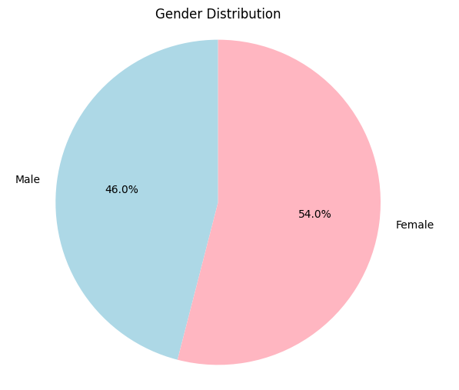

import csv
from matplotlib import pyplot as plt

file_path = 'records.csv'
gender_counter = {}

with open(file_path, mode='r', encoding='utf-8-sig') as file:
csv_reader = csv.reader(file)
headers = next(csv_reader)
for row in csv_reader:
gender = row[4]
if gender in gender_counter:
gender_counter[gender] += 1
else:
gender_counter[gender] = 1

labels = list(gender_counter.keys())
sizes = list(gender_counter.values())
plt.figure(figsize=(6, 6))
plt.pie(sizes, labels=labels, autopct='%1.1f%%', startangle=90, colors=['lightblue', 'lightpink'])
plt.title('Gender Distribution')
plt.axis('equal')
plt.show()

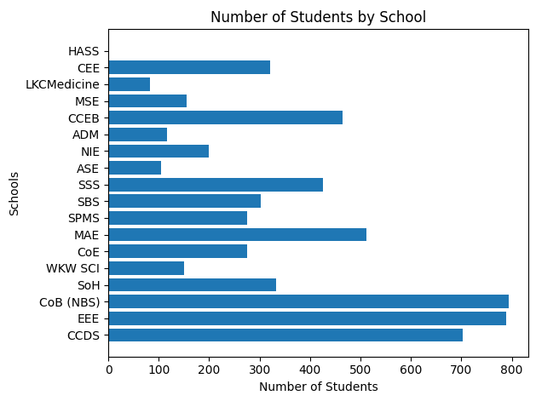

import csv
from matplotlib import pyplot as plt

file_path = 'records.csv'
school_counter = {}

with open(file_path, mode='r', encoding='utf-8-sig') as file:
csv_reader = csv.reader(file)
headers = next(csv_reader)
for row in csv_reader:
school = row[2]
if school in school_counter:
school_counter[school] += 1
else:
school_counter[school] = 1

schools = list(school_counter.keys())
popularity = list(school_counter.values())

plt.barh(schools, popularity)
plt.title("Number of Students by School")
plt.xlabel("Number of Students")
plt.ylabel("Schools")
plt.tight_layout()
plt.show()

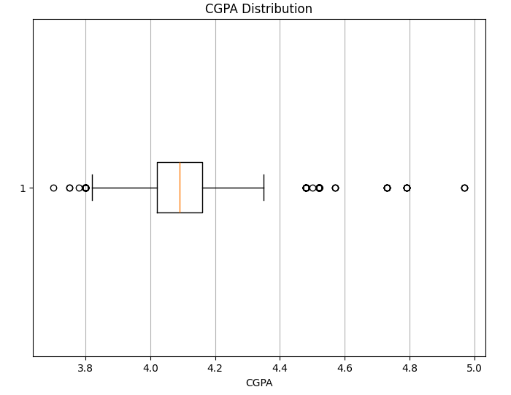
import csv
import matplotlib.pyplot as plt

file_path = 'records.csv'
cgpa_data = []

with open(file_path, mode='r', encoding='utf-8-sig') as file:
csv_reader = csv.reader(file)
headers = next(csv_reader)
for row in csv_reader:
cgpa = float(row[5])
cgpa_data.append(cgpa)

plt.figure(figsize=(8, 6))
plt.boxplot(cgpa_data, vert=False)
plt.title('CGPA Distribution')
plt.xlabel('CGPA')
plt.grid(axis='x')
plt.show()

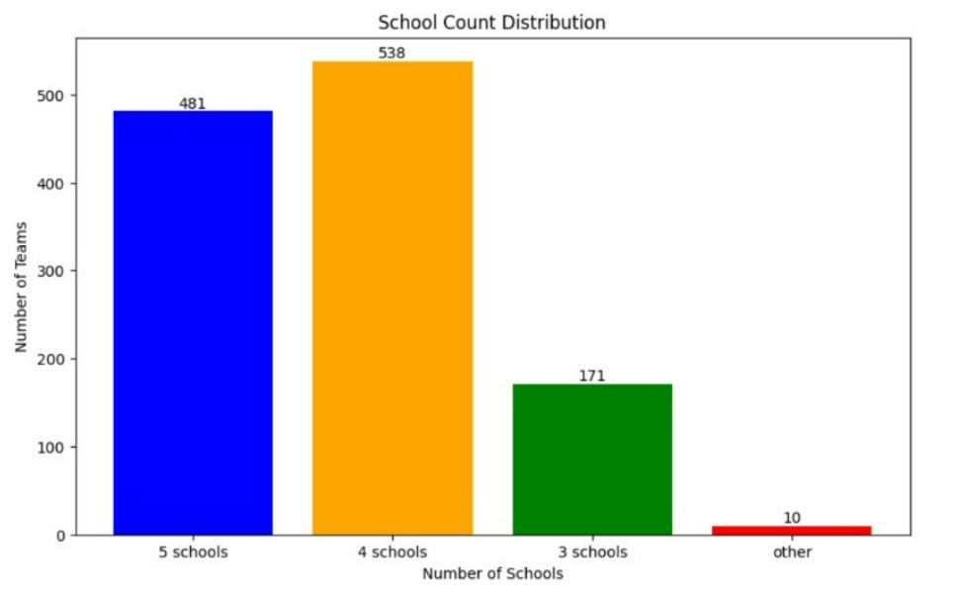
import matplotlib.pyplot as plt

school_counts = {
'5 schools': 481,
'4 schools': 538,
'3 schools': 171,
'other': 10
}

labels = list(school_counts.keys())
values = list(school_counts.values())

plt.figure(figsize=(10, 6))
bars = plt.bar(labels, values, color=['blue', 'orange', 'green', 'red'])

plt.title('School Count Distribution')
plt.xlabel('Number of Schools')
plt.ylabel('Number of Teams')

for bar in bars:
yval = bar.get_height()
plt.text(bar.get_x() + bar.get_width() / 2, yval, int(yval), ha='center', va='bottom')

plt.xticks(labels)
plt.show()

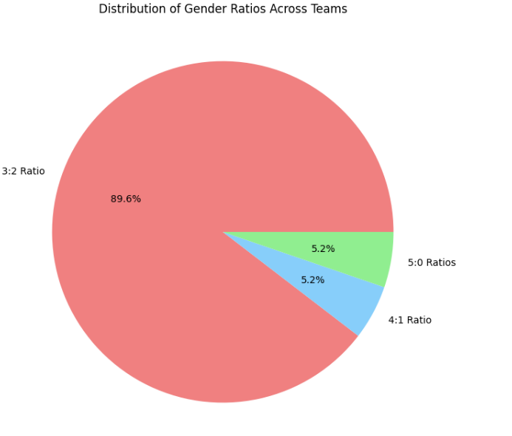

import matplotlib.pyplot as plt

ratio_counts = {'3:2': 1075, '4:1': 62, '5:0': 63} # Example values, replace with actual counts

labels = ['3:2 Ratio', '4:1 Ratio', '5:0 Ratios']
sizes = [ratio_counts['3:2'], ratio_counts['4:1'], ratio_counts['5:0']]
colors = ['lightcoral', 'lightskyblue', 'lightgreen']

plt.figure(figsize=(8, 8))
plt.pie(sizes, labels=labels, autopct='%1.1f%%', colors=colors)
plt.title('Distribution of Gender Ratios Across Teams')
plt.show()

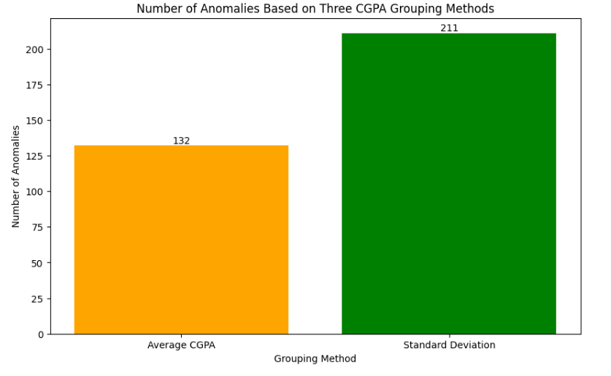

import matplotlib.pyplot as plt

methods = ['Average CGPA', 'Standard Deviation']
values = [132, 211]

colors = ['orange', 'green']

plt.figure(figsize=(10, 6))
bars = plt.bar(methods, values, color=colors)

plt.title('Number of Anomalies Based on Three CGPA Grouping Methods')
plt.xlabel('Grouping Method')
plt.ylabel('Number of Anomalies')

for bar in bars:
yval = bar.get_height()
plt.text(bar.get_x() + bar.get_width()/2, yval, int(yval), ha='center', va='bottom')

plt.show()

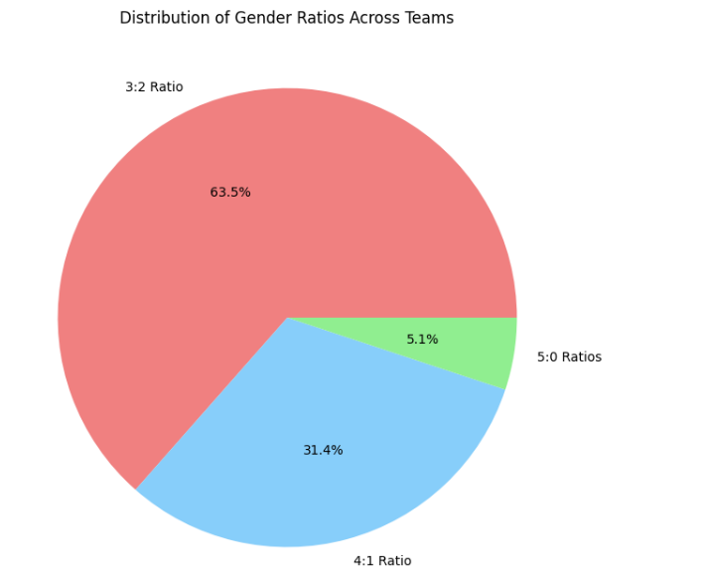

import matplotlib.pyplot as plt

ratio_counts = {'3:2': 762, '4:1': 377, '5:0': 61} # Example values, replace with actual counts

labels = ['3:2 Ratio', '4:1 Ratio', '5:0 Ratios']
sizes = [ratio_counts['3:2'], ratio_counts['4:1'], ratio_counts['5:0']]
colors = ['lightcoral', 'lightskyblue', 'lightgreen']

plt.figure(figsize=(8, 8))
plt.pie(sizes, labels=labels, autopct='%1.1f%%', colors=colors)
plt.title('Distribution of Gender Ratios Across Teams')
plt.show()

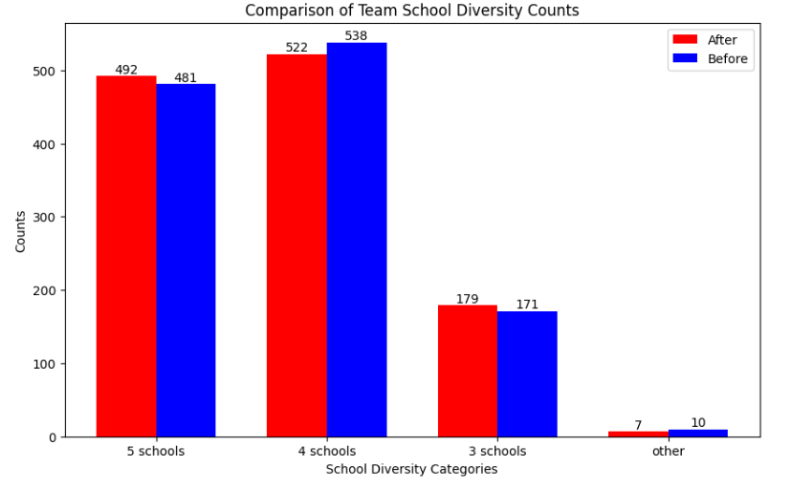

import matplotlib.pyplot as plt

data_1 = {'5 schools': 492, '4 schools': 522, '3 schools': 179, 'other': 7}
data_2 = {'5 schools': 481, '4 schools': 538, '3 schools': 171, 'other': 10}

categories = list(data_1.keys())
values_1 = list(data_1.values())
values_2 = list(data_2.values())

x = range(len(categories))
width = 0.35

plt.figure(figsize=(10, 6))
bars1 = plt.bar([i - width / 2 for i in x], values_1, width, color='red', label='After')
bars2 = plt.bar([i + width / 2 for i in x], values_2, width, color='blue', label='Before')

plt.xlabel('School Diversity Categories')
plt.ylabel('Counts')
plt.title('Comparison of Team School Diversity Counts')
plt.xticks(x, categories)
plt.legend()

for bar in bars1:
yval = bar.get_height()
plt.text(bar.get_x() + bar.get_width() / 2, yval, int(yval), ha='center', va='bottom', fontsize=10, color='black')

for bar in bars2:
yval = bar.get_height()
plt.text(bar.get_x() + bar.get_width() / 2, yval, int(yval), ha='center', va='bottom', fontsize=10, color='black')

plt.show()

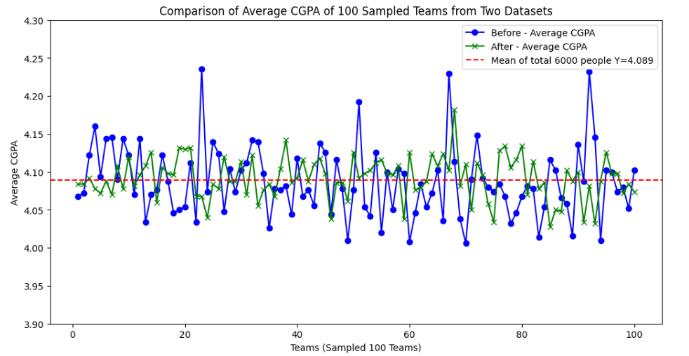

import csv
import random
import matplotlib.pyplot as plt

#old data.xlsx group by avg
file_path1 = 'team_groups_corrected.csv'
team_data1 = {}

with open(file_path1, mode='r', newline='', encoding='utf-8') as file:
csvreader = csv.reader(file)
headers = next(csvreader)
for row in csvreader:
team_number = row[-1]
cgpa = float(row[5])
# Initialize list if team_number is not already in team_data1
if team_number not in team_data1:
team_data1[team_number] = []
team_data1[team_number].append(cgpa)

sampled_teams1 = random.sample(list(team_data1.keys()), 100)
team_avg_cgpas1 = [sum(team_data1[team]) / len(team_data1[team]) for team in sampled_teams1]

file_path2 = 'Final_grouped.csv'
team_data2 = {}

#new data set from sortedteams_new5.csv
with open(file_path2, mode='r', newline='', encoding='utf-8') as file:
csvreader = csv.reader(file)
headers = next(csvreader)
for row in csvreader:
team_number = row[-1]
cgpa = float(row[5])
# Initialize list if team_number is not already in team_data2
if team_number not in team_data2:
team_data2[team_number] = []
team_data2[team_number].append(cgpa)

sampled_teams2 = random.sample(list(team_data2.keys()), 100)
team_avg_cgpas2 = [sum(team_data2[team]) / len(team_data2[team]) for team in sampled_teams2]

# data from the before one
plt.figure(figsize=(12, 6))
plt.plot(range(1, 101), team_avg_cgpas1, marker='o', linestyle='-', color='blue', label='Before - Average CGPA')
plt.plot(range(1, 101), team_avg_cgpas2, marker='x', linestyle='-', color='green', label='After - Average CGPA')
plt.axhline(y=4.089, color='red', linestyle='--', label='Mean of total 6000 people Y=4.089')
# this is the data from the new code
plt.ylim(3.9, 4.3)
plt.xlabel('Teams (Sampled 100 Teams)')
plt.ylabel('Average CGPA')
plt.title('Comparison of Average CGPA of 100 Sampled Teams from Two Datasets')
plt.legend()
plt.show()
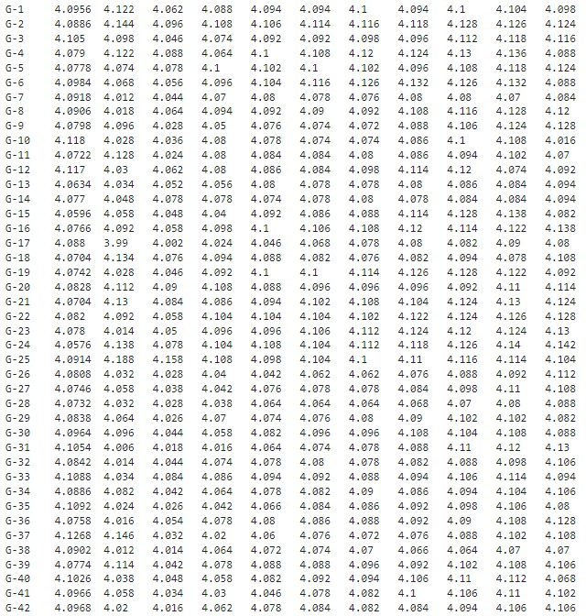
import csv
tg_data = {}
file_path = 'Final_grouped.csv'

with open(file_path, 'r') as file:
reader = csv.DictReader(file)
for row in reader:
tg = row['TG']
gpa = float(row['GPA'])
if tg not in tg_data:
tg_data[tg] = {'total_gpa': 0, 'count': 0}
tg_data[tg]['total_gpa'] += gpa
tg_data[tg]['count'] += 1

tg_averages = {tg: data['total_gpa'] / data['count'] for tg, data in tg_data.items()}

team_data = {}

with open(file_path, 'r') as file:
reader = csv.DictReader(file)
for row in reader:
team = row['Team Number']
gpa = float(row['GPA'])
if team not in team_data:
team_data[team] = {'total_gpa': 0, 'count': 0}
team_data[team]['total_gpa'] += gpa
team_data[team]['count'] += 1

team_averages = {team: data['total_gpa'] / data['count'] for team, data in team_data.items()}
sorted_tg_keys = sorted(tg_averages.keys(), key=lambda x: int(x.split('-')[1]))
sorted_team_keys = sorted(team_averages.keys(), key=int)

table_data = []
difference_sums = []

for i, tg_key in enumerate(sorted_tg_keys):
tg_avg = round(tg_averages[tg_key], 5)
row = [tg_key, tg_avg]

team_avgs = [round(team_averages[sorted_team_keys[i * 10 + j]], 5) for j in range(10)]
row.extend(team_avgs)

difference_sum = sum(abs(team_avg - tg_avg) for team_avg in team_avgs)
difference_sums.append(difference_sum)

table_data.append(row)
for row in table_data:
print("\t".join(map(str, row)))

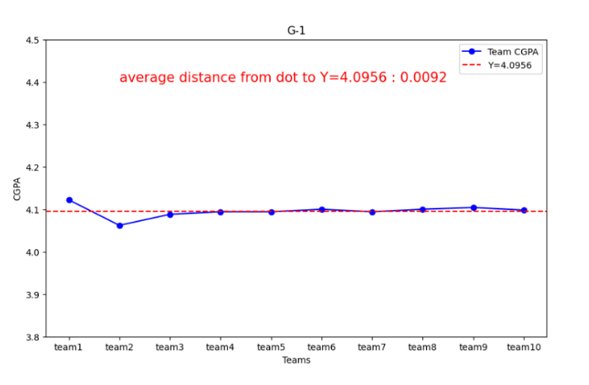
import matplotlib.pyplot as plt

teams = ['team1', 'team2', 'team3', 'team4', 'team5', 'team6', 'team7', 'team8', 'team9', 'team10']
cgpa_values = [4.122, 4.062, 4.088, 4.094, 4.094, 4.1, 4.094, 4.1, 4.104, 4.098]
average_cgpa = 4.0956

distances = [abs(value - average_cgpa) for value in cgpa_values]
average_distance = round(sum(distances) / len(distances), 4)

plt.figure(figsize=(10, 6))
plt.plot(teams, cgpa_values, marker='o', color='blue', label='Team CGPA')
plt.axhline(y=average_cgpa, color='red', linestyle='--', label='Y=4.0956')
plt.text(1, 4.4, f'average distance from dot to Y=4.0956 : {average_distance}', color='red', fontsize=15)
plt.xlabel('Teams')
plt.ylabel('CGPA')
plt.title('G-1')
plt.legend()
plt.ylim(3.8, 4.5)

plt.show()

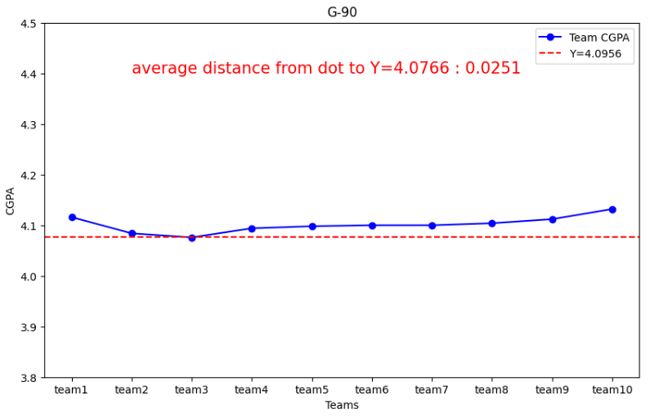

import matplotlib.pyplot as plt

teams = ['team1', 'team2', 'team3', 'team4', 'team5', 'team6', 'team7', 'team8', 'team9', 'team10']
cgpa_values = [4.116, 4.084, 4.076, 4.094, 4.098, 4.1, 4.1, 4.104, 4.112, 4.132]
average_cgpa = 4.0766

distances = [abs(value - average_cgpa) for value in cgpa_values]
average_distance = round(sum(distances) / len(distances), 4)

plt.figure(figsize=(10, 6))
plt.plot(teams, cgpa_values, marker='o', color='blue', label='Team CGPA')
plt.axhline(y=average_cgpa, color='red', linestyle='--', label='Y=4.0956')
plt.text(1, 4.4, f'average distance from dot to Y=4.0766 : {average_distance}', color='red', fontsize=15)
plt.xlabel('Teams')
plt.ylabel('CGPA')
plt.title('G-90')
plt.legend()
plt.ylim(3.8, 4.5)

plt.show()

Statement: "Final_grouped" is the final version of the CSV file, while "team_groups_corrected" is grouped by average based on the old code. Adjustments were made to both files, and the team number, ranging from 1 to 1200, has been added in the last column of each file to facilitate easier charting.

